**Block Diagram Of Digitial Tachometer**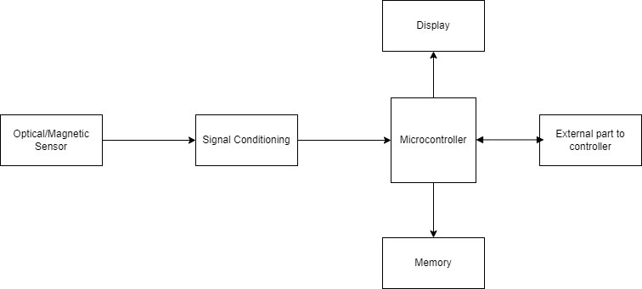

### Digital Tachometer

A tachometer made purely from [electronic components](https://www.elprocus.com/buy-electronic-components-and-kits-through-online-shoping-sites/) and is used to measure the speed of an engine or any other moving object in revolutions per minute is known as an electronic tachometer. Electronic tachometers are used in the dashboard of a car for measuring the driving speed. These tachometers are lightweight, easy to view, and accurate under all conditions.

**Optical sensing:** An optical sensor consists of an optical disk placed near the motor which generates pulses proportional to the rotating shaft. A slotted disk and IR emitter are used to generate these pulses.

**Magnetic sensing:** In this type of sense, there is a possibility to use either Hall Effect sensors or magnetic sensors. Hall Effect principle generates the pulses proportional to the speed of the shaft and magnetic sensors are used to generate pulses by making use of variable reluctance.

**Signal Conditioning:** The output signals from the sensors are noisy, and therefore, are filtered, amplified, and digitized so that the microcontroller recognizes these signals for further action.

**Microcontroller:** A microcontroller is used to analyze and process the readings from the sensors. It sends that information to a display device, and when the speed is reduced or increased to a predefined level, it alerts the user by taking appropriate action.

**Memory:** The memory unit stores the data from [the microcontroller](https://www.elprocus.com/microcontroller-based-mini-projects-ideas/)

**Display Unit:** The function of the display unit is to view the stored values transmitted from the microcontroller.